**Enterprise Resource Planning**

*Of*

**ZAB**

**Training User Manual**

**(SV–12.0.0 | MV–1.0.0)**

**For**

**FloWater Solutions Ltd.**

**Upload Signature of Staff**

# Upload Signature (Image) of Staff

1. Put a Signature Image to the Server

|  |  |
| --- | --- |
| **Step 1** | Keep a picture of Staff Signature in a folder of your PC (png/jpg format) with name of Staff ID |
| **Step 2** | browse the URL link <http://163.53.183.153:8090/zabimage/> |
| **Step 3** | Click **Choose File** and then choose the Image File **(**of Staff Signature**)** |
| **Step 4** | Click **Upload** button |
| **Result** | the Signature Image will be Uploaded to the Specified folder of the Server |

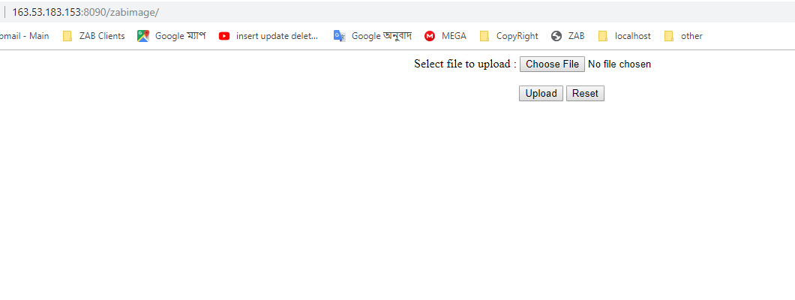

1. Upload the Signature Image to Personnel Information

|  |  |
| --- | --- |
| **Step 1** | Open System **>** HR & Payroll  **>** [**HR Development (HRD)**](javascript:run1()&menuname=pdhrd) **>** Personnel Info |
| **Step 2** | Write the Staff ID & then Click **Show** |
| **Step 3** | Click **Choose File** and Choose the Signature Image File (of the Staff) and then Click **Update** |
| **Step 4** | Now Click **Signature_Upload** button |
| **Result** | The Signature of the Staff will be Uploaded Successfully |

